Quantifying Hybrid Necrosis in Mimulus tilingii

EXAMPLE HONORS THESIS
DIVISION OF BIOLOGICAL SCIENCES

Table of Contents

Page #
- Abstract
- Introduction
5. Research Approach
11. Results
23. Discussion
28 References

Abstract
According to the Biological Species Concept (Mayr, 1942), the formation of new species arises as a result of the evolution of reproductive barriers, which prevent the production of viable offspring (Safran & Nosil, 2012). Even when a cross between two plant species produces a viable embryo, later-acting postzygotic barriers such as hybrid necrosis can still hinder interspecific genetic exchange. Hybrid necrosis is a condition in hybrid plants that manifests as necrotic lesions and tissue, arrested growth, and plant lethality. In recent years, it is being investigated as a potential reproductive isolating barrier. Temperature regulates normal plant growth and development and influences the presence and severity of hybrid necrosis. The goal of my research is to quantify hybrid necrosis between two species in the Mimulus tilingii species complex- M. tilingii and M. caespitosa- and determine if the hybrid necrosis present in the M. tilingii complex is temperature dependent. Reciprocal crosses between M. tilingii and M.
caespitosa populations were performed and I compared flowering patterns of the hybrid progeny to the progeny of the parent species over a ten-week period. Plants were split and raised under standard growing temperatures or an elevated temperatures to investigate if an increase in temperature could rescue hybrid plants from necrosis. I determined that elevated growth temperature has a diminishing effect on the presence and severity of the hybrid necrosis. Additionally, I determined that the presence of the necrosis was dependent on the M. tilingii genotype. Based the genotype-specificity and observed recovery of the necrosis under elevated temperature, there is evidence to suggest the necrosis in the M. tilingii complex has an underlying, temperature dependent genetic mechanism.

Introduction
One goal of evolutionary biology is to understand the ecological and genetic mechanisms that contribute to species diversity. New species can arise when one species is split into two distinct populations due to a geographical barrier such as a mountain or river (allopatric speciation; Mayr, 1942). Over time reproductive isolation could evolve if gene flow is minimal. Additionally, while physically separated, disruptive selection may favor local adaptation in these physically separated populations, leading to genotypic or phenotypic differences that could act as reproductive isolating barriers (Safran & Nosil, 2012). There are two categories of reproductive isolating barriers: prezygotic barriers, which prevent fertilization from occurring (e.g. habitat isolation, mechanical isolation, mating behavior, gametic incompatibilities), and postzygotic barriers that produce unfit hybrids (e.g., hybrid sterility, hybrid weakness, or hybrid necrosis; Coyne & Orr, 1998).
One important postzygotic reproductive barrier between plant species is hybrid necrosis. Hybrid necrosis manifests as a set of phenotypes that include tissue lesioning, stunted growth, chlorosis, wilting, root weakness, and plant death (Bomblies & Weigel, 2007; Chen et al., 2014; Mizuno et al., 2011). In most cases, hybrids afflicted with hybrid necrosis are unable to reach maturity. The absence of the necrosis phenotypes in parent plants exposed to similar growing conditions suggests that the hybrid necrosis is a result of epistasis between two or more genes that normally would not interact outside of hybridization (Bomblies & Weigel, 2007).
Under the Dobzhansky-Muller Model, negative epistasis occurs when alleles of different species behave normally in non-hybrid backgrounds but interact negatively within a hybrid background to disrupt normal gene interactions and produce harmful phenotypes (Dobzhansky, 1937 & Muller, 1942). Epistasis- positive and negative- contributes to many evolutionary processes such as phenotype plasticity, mating system evolution, and speciation (Wade, 2002; Johnson & Wade, 1996; Wade, 1992). Recent studies on hybrid necrosis have reported that it can be genetically simple and caused by recessive or dominant alleles undergoing interactions that fit the Dobzhansky-Muller Model (Bomblies & Weigel, 2007; Chen et al., 2014; Todesco et al., 2014; Jeuken et al., 2009). Additionally, several studies have suggested that the epistatic interactions in hybrid necrosis are influenced by environmental factors such as pathogens and temperature (Bomblies et al., 2007; Jeuken et al., 2009; Mino et al., 2002; Phillips, 1977; Todesco et al., 2014; Yamada et al., 2003; Alcazer et al., 2009; Chen et al., 2014; Hatfield &
Prueger, 2015; Hua et al., 2001).
The phenotypes of hybrid necrosis often mimic symptoms of pathogen attack and connections between the genes involved in hybrid necrosis and immune response genes are becoming increasingly clear (Bomblies, 2009; Bomblies & Weigel, 2007; Bomblies et al., 2007). Genes involved in pathogen defense are considered some of the most variable because of their constant balance between fitness against pathogens and maintaining a healthy rate of energy use while doing so (Dodds & Rathjen, 2010; Pieterse et al., 2009). One system that illustrates the cost of high variability and how it effects hybrid fitness is in nucleotide binding-leucine rich repeat associated genes. In plants, nucleotide binding-leucine rich repeat (NB-LRR) receptors and proteins are a part of the largest and most influential family of disease resistance genes (Dubey & Singh, 2018). Like other genes involved in the immune system, NB-LRR associated genes have been constantly and rapidly expanding across plants lineages as pathogens evolve (Dodds & Rathjen, 2010; Guo et al., 2011; Jones & Dangl, 2006). Because selection favors novel NB-LRR alleles that can recognize new effectors, NB-LRR genes evolve rapidly as plants try to enable resistance to as many pathogens as possible (Jones & Dangl, 2006; Guo et al., 2011). There may be a tradeoff between enhanced pathogen resistance and plant homeostasis, growth, and development (Todesco et al., 2010; Yamada et al., 2003). Maintaining immune system responses like the NB-LRR while balancing a healthy metabolism expenditure and expanding genetic variation can cause instability of the immune system that leads to autoimmune disorders and/or stunted growth. (Alcazar & Parker, 2011). In hybrids, divergent immune response alleles- such as NB-LRR- inherited from different parental lineages could cause an immune system mismatch, leading to the phenotypes seen in hybrid necrosis (Alcazar & Parker, 2011). An allele responsible for the NB-LRR protein was important in producing one of the types of hybrid necrosis observed in Arabidopsis thaliana, providing a clear link to the hybrid necrosis phenotype and the immune system response (Bomblies et al., 2007).
There is also strong evidence that suggests environmental conditions such as temperature can affect genes that regulate plant immune responses, growth, and homeostasis (Hua et al., 2001; Chen et al., 2014). Temperature is one of the most important environmental factors for plant growth and hybrid necrosis (Hatfield & Prueger, 2015). One of the earlier studies investigating the effects of temperature on hybrid fitness observed that as temperature increased above ambient, the necrotic phenotype largely diminished or completely disappeared (Phillips, 1997). Further studies have shown that for intraspecific A.thaliana hybrids and interspecific lettuce, Nicotiana, and Gossypium (cotton) hybrids experiencing hybrid necrosis, an increase in temperature has been able to restore the plant partially or completely to the healthier growth observed in the parents (Bomblies et al., 2007; Jeuken et al., 2009; Mino et al., 2002; Phillips, 1977; Todesco et al., 2014; Yamada et al., 2003). Interestingly, another study (Chen et al. in
2014) discovered that a decrease in temperature was also able to recover normal growth in interspecific rice hybrids suffering from necrosis, further showing the complex relationship between temperature and necrosis (Chen et al., 2014). It is also been observed that a change in temperature can lead to hybrid vigor in plants that normally experience necrosis (Mino et al., 2002).
Increasing global temperatures and climate chance could reduce the presence of hybrid necrosis and increase fitness of hybrids, potentially diminishing hybrid necrosis as a reproductive isolation barrier. The connection between temperature and pathogen resistance phenotypes exhibits the influence the environment has on the balance between fitness and disease resistance. The purpose of this study is to quantify interspecific hybrid necrosis seen in Mimulus tilingii hybrids and to determine if the hybrid necrosis phenotype presence is temperature dependent. This research aims to measure flowering patterns as a manifestation of hybrid necrosis between two species of Mimulus, and to determine if an increase in temperature can reduce hybrid necrosis phenotypes.

Research Approach

Study System
In this study, I use two-closely related species of yellow monkey flowers,- Mimulus tilingii and M. caespitosa as a study system for investigating hybrid necrosis. M. tilingii and its close relatives M. caespitosa and M. minor are found in high-elevation areas of western North America (Vickery, 1974; Nesom 2012, 2014; Sandstedt et al. 2020; Table 1). To explore interspecific hybrid necrosis in Mimulus, I performed crosses between M. tilingii and M. caespitosa. Of the two species, M. tilingii is considered more geographically dispersed, spreading across most of western North America, whereas M. caespitosa is more localized, growing predominantly in Washington and southwest Canada (Nesome 2012; Figure 1). Species in the M. tilingii species complex are predominantly outcrossing but have selfing rates within and between species as high as 30% (Ritland, 1989; Ritland & Ritland, 1989). Recent research has shown that M. tilingii and M. caespitosa are genetically distinct and exhibit strong postzygotic isolating barriers, including hybrid necrosis (Sandstedt et al., 2020).
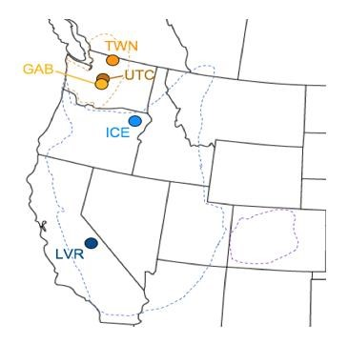
To quantify the presence of hybrid necrosis between
M. tilingii and M. caespitosa, I chose four distinct populations. I chose two M. tilingii populations: Ice Lake maternal line 10 (ICE10) and Lee Vining Road, CA maternal line 1 (LVR). I chose two M. caespitosa populations: Upper Tahoma Creek, WA maternal line 1 (UTC1) and Twin Lakes, WA maternal line 36 (TWN36; Fig. 1). I used inbred lines for ICE10 (6 generations inbred), TWN36 (10 generations inbred), and LVR (8 generations inbred).
However, UTC1 was only one-generation inbred, and in previous interspecific crosses, we discovered it was | Figure 1: Distribution of M. tilingii (ICE and LVR) and M. caespitosa (UTC and TWN) populations across the northwestern United States. Dotted lines represent the areas occupied by each species in the M. tilingii complex.
heterozygous for hybrid necrosis alleles (i.e some sibs produced necrotic hybrids and others did not). Thus, I used three full sibs from this line to ensure at least one carried hybrid necrosis alleles (UTC1.1, UTC1.2, UTC1.3).
Species | Population | Elevation (m) | State | (LAT, LONG)
M. caespitosa | TWN | 1594 | WA | (48.57026, -121.38164)
M. caespitosa | UTC | 1025 | WA | (46.8004, -121.871111)
M. tilingii | ICE | 2369 | OR | (45.13553, -117.16067)
M. tilingii | LVR | 2751 | CA | (35.57049, -119.13544)
Table 1: Elevation and Location of populations used in this study.

Plant Crosses and Care
To generate plants for the study, five interspecific crosses were performed between M.
tilingii and M. caespitosa (Table 2). As controls, I also generated self-fertilized seeds from each maternal line.
Interspecific Crosses | Control Crosses
ICE10xTWN36 | ICE10xICE10
ICE10xUTC1.1 | UTC1.1xUTC1.1
ICE10xUTC1.2 | UTC1.2xUTC1.2
ICE10xUTC1.3 | UTC1.3xUTC1.3
LVRxTWN36 | LVRxLVR
 | TWN36xTWN36
Table 2: Interspecific and control crosses generated for the experiment. Crosses were generated through hand pollination.
To generate experimental plants, I sowed approximately one-hundred seeds of each cross (5 interspecific, 6 self-fertilization) onto a damp paper towel before storing them in sterile petri dishes. I sealed the dishes with parafilm to retain moisture and wrapped the dishes in black bags to keep light out. I moved the seeds into a refrigerator to be cold stratified at 4°C for one week to disrupt seed dormancy. After one week of cold stratification, I removed the black wrapping and transferred the petri dishes to a 23°C growth chamber with constant light. After 14 days I randomly selected seedlings of each genotype for the two temperature conditions. I transplanted
32 seedlings into 2.5” plastic pots filled with moist Fafard 4P growing mix (Sun Gro Horticulture, Agawam, Massachusetts, USA). I moved the flats back into the 23°C growth chamber with constant light and allowed the seedlings to grow and further establish for another 14 days .

Sorting for Temperature Trials
I exposed equal numbers of seedlings from each genotype to elevated temperatures and control temperatures. I used eight to sixteen individuals of each genotype in both chambers depending on the genotype’s success in germinating (Table 3). In total I used 128 plants in four flats for each treatment and the plants of each genotype were randomly sorted throughout each flat. Plants in the control growth chamber experienced 16-hour days at 23°C with 8-hour nights at 16°C. Plants in the hot treatment growth chamber experienced 16-hour days at 29°C with 8hour nights at 23°C. As the study progressed and plants began to overgrow the area of the pot, we seperated some of the plants by moving them to new flats. Plants were seperated once, six weeks after being sorted into their temperature treatments, by moving alternating plants to new flats so that there were eight flats per treatment by the end of the study. From the date that the seedlings were sorted into their temperature chambers, the study lasted 16 weeks and 4 days.
Genotype | Sample Size (N) Control Temperature | Sample Size (N) Elevated Temperature
ICE10xICE10 | 12 | 12
UTC1.1xUTC1.1 | 8 | 8
UTC1.2xUTC1.2 | 8 | 8
UTC1.3xUTC1.3 | 12 | 12
LVRxLVR | 12 | 12
TWN36xTWN36 | 12 | 12
ICE10xUTC1.1 | 12 | 12
ICE10xUTC1.2 | 12 | 12
ICE10xUTC1.3 | 12 | 12
ICE10xTWN36 | 16 | 16
LVRxTWN36 | 12 | 12
Total | 128 | 128
Table 3: Sample sizes for each genotype. The number of seedings used in each genotype depended on the germinating success of each genotype. .

Potential Source of Error
At the beginning of the temperature dependent trials, there were three instances where the standard temperature chamber thermometer malfunctioned, and the chamber temperature rose above 23°C. As soon as the increase in temperature was noticed, typically within the same day or early into the next day, the plants were moved into a temporary growth chamber kept at 23°C until the main growth chamber was fixed. There were no malfunctions or deviations from the experimental temperature in the hot-treatment growth chamber.

Measuring the necrosis phenotype
To investigate the hybrid necrosis phenotype and its effects on flowering, I recorded the number of open flowers of each plant twice per week over the course of ten weeks. After opening, flowers typically stay on the stem or three to four days before falling (based on observation). Although I used flowering as the proxy for measuring hybrid necrosis in this study, it is important to acknowledge that there were other phenotypes observed- yellowing of leaves, white/inviable buds, leaf/vegetation density, and purple stems and leaves- that were not characterized by this study. I started counting open flowers on each plant when most of the plants were approximately ten weeks old. At this point in the study, the majority of plants in the control chamber (66%) and elevated temperature chamber (65%) had produced their first flower. At the end of the study ten weeks later, approximately 96% of the plants had flowered in the control chamber and 77% had flowered in the elevated temperature chamber. Progeny of one interspecific cross - ICE10xTWN36- were approximately six weeks old when I started counting the number of open flowers because the decision to use them was determined after the study had started and they were consequently planted at a later date.

Statistical Analysis
To assess differences in flowering production we modeled the effect of cross, temperature, and time on the average number of open flowers per census with a generalized linear model (GLM) using the lmer function in the “lme4” package implemented in R. For the statistical analyses of this study, I combined the progeny of the three UTC1 control crosses after an initial three-way repeated measures analysis confirmed the progeny of the three crosses were colinear. In the data I grouped the control cross data for UTC1.1xUTC1.1, UTC1.2xUTC1.2, and UTC1.3xUTC1.3 and labeled them all as “UTC1xUTC1”.
I then computed a three-way repeated measures Anova using the anova_test function in the “rstatix” package of R with type III sums of squares to determine significance. I started the analysis by checking the assumptions of repeated measures Anova: normality, no significant outliers, and the assumption of sphericity. I generated box plots to check for normality of the data using the ggboxplot function of the “ggpubr” package. An initial analysis of the boxplots showed that the data was not normally distributed. To normalize the data, I used JMP to transform the data using quantile normalization. After normalizing the data, I then checked for outliers by using the identify_outliers function of the rstatix package. Of the 5,292 measurements taken- 21 census days were taken for 252 total plants- 283 measurements were identified to be outliers. Of the 283 outliers, 141 of the outliers were considered extreme by this analysis (2.66% of the all the measurements taken). Another normality check was then performed using the ggqqplot function of the ggpubr package to generate QQ plots for visual inspection. Because the data had been normalized at this point, the QQ plots generated fit the normality assumption. The final assumption of sphericity was checked using Mauchly’s test of sphericity, which is automatically given after using the anova_test function of the rstatix package. Finally, a post-hoc test was conducted by running a simple two-way interaction between time and treatment, using cross as the moderator variable. For the generalized linear model and the three-way repeated measures Anova, 126 plants were included for each temperature treatment. Plants were excluded due to contamination (one control chamber seedling was phenotypically determined not to be a Mimulus plant) or failure to develop past the seedling stage.

Results

Species in the M. tilingii complex exhibit different successes in flowering
The progeny of the control crosses between the two study species- M. caespitosa and M. tilingii- showed clear differences in flowering success under standard growth conditions, as well as in an elevated temperature environment. In addition to the effects of time and temperature treatment, the species of the control progeny had a significant effect on the average number of flowers produced (Table 6). On average, M. tilingii populations- ICE10 and LVR- produced more flowers than M. caespitosa populations- UTC and TWN36- regardless of temperature (Table 4). Mimulus tilingii produced 2.23 + 0.133 in the control treatment and 1.53 +
0.108flowers in the elevated temperature chambers. Mimulus-caespitosa plants had on average 1.35 + 0.073 flowers in the control chamber and 1.20 + 0.024 flowers open in the elevated temperature chamber. However, time, temperature, and their interactions significantly reduced the average amount of flowers produced by both grouped M. tilingii and M. caespitosa plants (Tables 4 & 5). Mimulus tilingii plants saw a 31% reduction to the average number of flowers produced. Mimulus caespitosa plants saw a 11% reduction to the average number of flowers produced.
The species also differed in how many plants were able to successfully produce flowers until the end of the study. There were more M. caespitosa plants producing open flowers at the end of the study under standard growing temperatures than M. tilingii plants. Eighteen of the 39 (46.2%) M. caespitosa plants were still producing open flowers by the end of the study in the control chamber, whereas only four of the 24 (16.7%) M. tilingii plants were still producing open flowers. For the two species, the difference in the length of flowering was reversed under elevated temperatures. The last M. caespitosa plant with an open flower under elevated temperatures was observed three weeks before the study ended. Alternatively, two M. tilingii plants were still producing open flowers until the end of the study, showing a temperaturedependent and species-specific difference in the success of flowering.

Comparing Hybrid Genotypes to Maternal Lines
On average, the grouped hybrid crosses tended to produce intermediate numbers of flowers in the standard chamber, but more flowers in the elevated temperature chamber when compared to the progeny of the control crosses (Table 4). Under standard growing temperatures, the grouped hybrid crosses produced flowers in an amount closer to that of the M. caespitosa grouped control crosses, producing more flowers on average than M. caespitosa plants, but less flowers than the M. tilingii plants. In the elevated temperature chamber, the grouped hybrid crosses produced more flowers on average than the grouped M. tilingii plants and the grouped M. caespitosa.
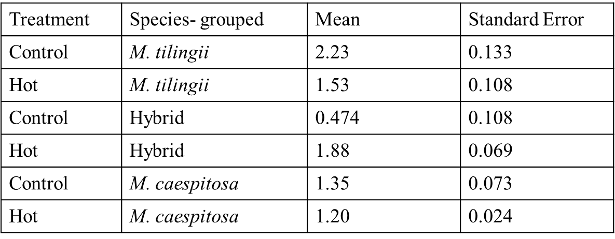
Table 4: Summary statistics for grouped M. tilingii and M. caespitosa control cross progeny, as well as grouped hybrid progeny.
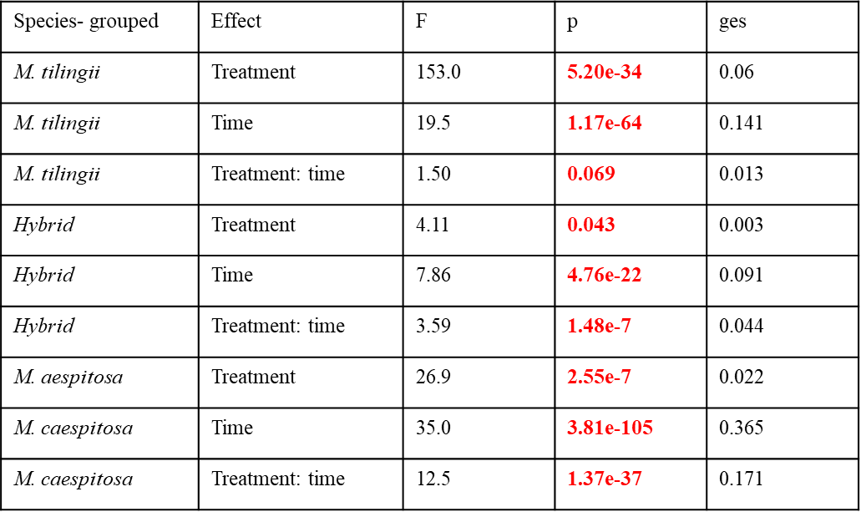
Table 5: Post-hoc test generating pairwise differences to look at the effects of time, treatment, and their interactions on the grouped progeny of M. tilingii and M. caespitosa control crosses, as well as grouped hybrid progeny. Treatment, time, and their interactions were all found to play statistically significant roles in the average number of flowers produced. P values found to be statistically significant are indicated in red.

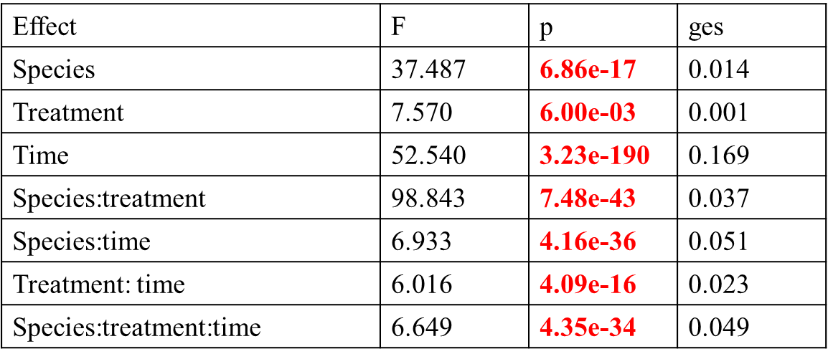
Table 6: Effect of species, time, treatment, and their interactions on the number of flowers produced by the control cross progeny and hybrid crosses. Statistically significant p values are indicated in red. Species, treatment, time, and their interactions were all found to have statistically significant effects on the average number of flowers produced.

Hybrid Genotype Variation
Hybrids also varied in flower production. Hybrid genotypes ICE10xUTC1.3 and ICE10xUTC1.1 produced fewer flowers on average in the standard and elevated temperature chambers than parent species ICE10 and UTC1 (Table 7). For the ICE10xUTC1.1 cross, hybrids produced approximately 21% of the flowers produced by ICE10 plants, and only 29% of the open flowers produced by UTC1 plants. Similarly, ICE10xUTC1.3 hybrids produced only 20% of the flowers produced by ICE10 plants and 28% of the flowers produced by UTC1 plants. However, under elevated temperatures, ICE10xUTC1.1 and ICE10xUTC1.3 were able to outperform and produce approximately 1.5 times as many open flowers as UTC1 control plants. Hybrids from the third ICE10xUTC1 cross- ICE10xUTC1.2- did not follow these same flowering trends. Instead, hybrids from ICE10xUTC1.2 consistently produced intermediate numbers of open flowers compared to the ICE10 and UTC1 control cross plants (Figures 2 & 3).
In contrast to the effects of temperature seen in ICE10xUTC1 crosses, LVRxTWN36 hybrids consistently outperformed the LVR and TWN control plants (Table 7; Figures 6 & 7). In the standard temperature growth chamber, the LVRxTWN36 hybrids produced three times as many open flowers than the LVR control plants and four times as many open flowers compared to the amount produced by TWN36 plants. Under elevated temperatures the LVRxTWN36 hybrids produced approximately three times as many plants as LVR plants and 1.5 times as many flowers as the TWN36 plants (Figure 7). Finally, ICE10xTWN36 hybrids consistently produced intermediate amounts of open flowers under standard and elevated growth temperatures (Table 7; Figures 4 & 5).
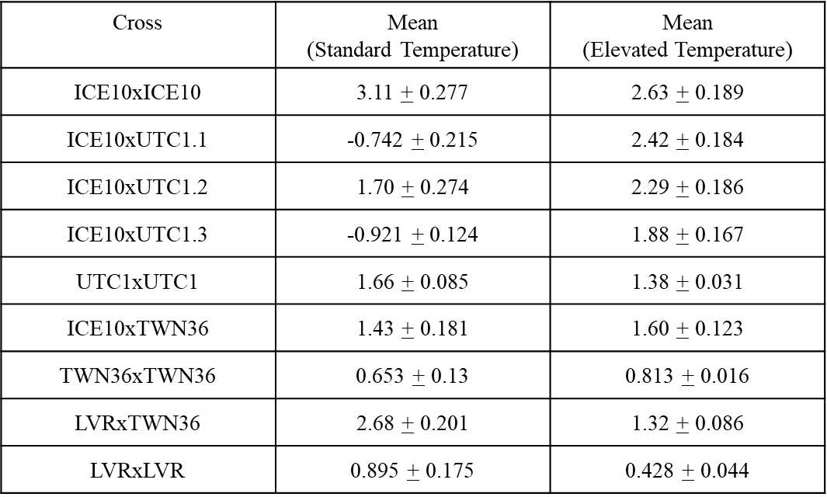
Table 7: Summary statistics for M. tilingii and M. caespitosa control cross progeny, as well as hybrid progeny.
We also observed differences in how long hybrid plants were able to produce open flowers. Under standard growth temperatures, hybrids from ICE10xUTC1.1 and ICE10xUTC1.3 stopped producing open flowers four and six weeks before the end of the study, respectively
(Figure 2). However, all other hybrid genotypes- ICE10xTWN36, ICE10xUTC1.2, and
LVRxTWN36- were still producing open flowers by the end of the study (Figures 2, 4, & 6).
When comparing the length of flowering under elevated growth temperatures, the majority of hybrid genotypes were unaffected (ICE10xUTC1.2) or experienced a decline (75% reduction in both ICE10xTWN36 and LVRxTWN36) in the number of plants still producing flowers under the standard growing temperatures at the end of the study. However, much like the increase seen in the average number of open flowers under elevated conditions, hybrids from ICE10xUTC1.1 and ICE10xUTC1.3 performed better under elevated conditions and more plants were able to flower longer (Figure 3). Indeed, at the end of the study, one ICE10xUTC1.1 hybrid still had open flowers and hybrids from ICE10xUTC1.3 were able to continue producing open flowers four weeks longer than under standard growing conditions.

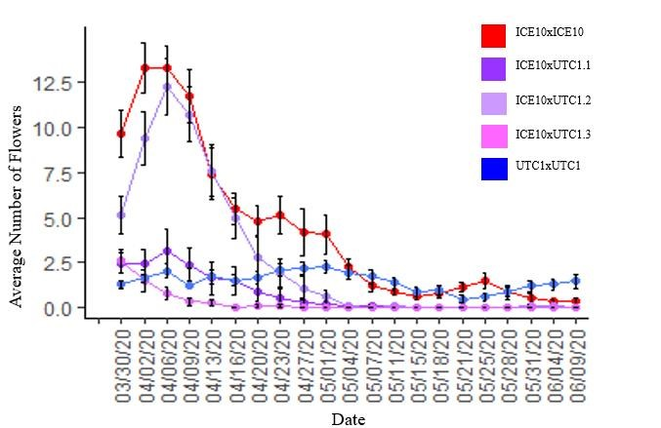
Figure 2: Average number of open flowers in the ICE10, UTC1, and ICE10xUTC1 genotypes in the control temperature chamber (23°C). ICE10xUTC1 and ICE10xUTC1.3 hybrids produced fewer open flowers and stopped producing flowers earlier than the parent species.
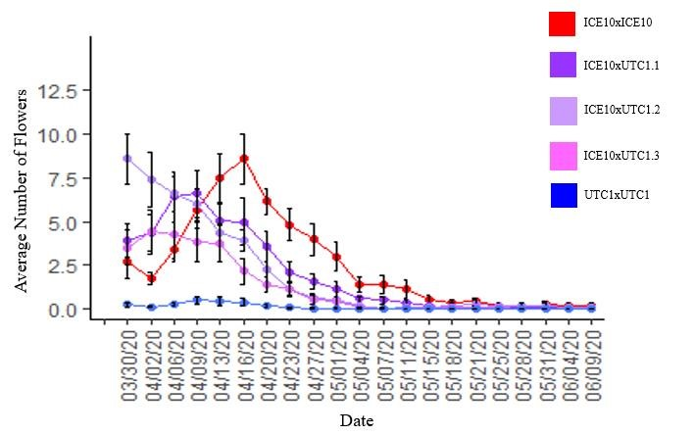
Figure 3: Average number of open flowers based on genotype in the hot temperature chamber (29°C).
Most genotypes saw a reduction in flowering, but ICE10xUTC1.1 and ICE10xUTC1.3 double the average number of open flowers produced over time compared to the control chamber.
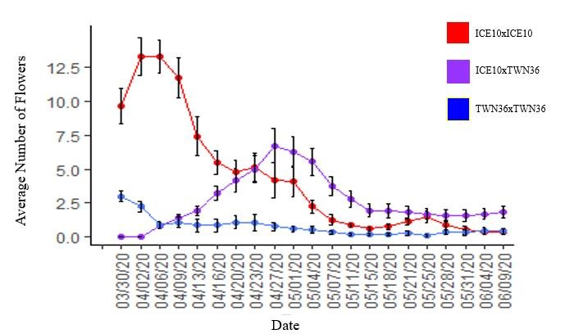
Figure 4: Average number of open flowers counted in the ICE10xICE10, TWN36xTWN36, and
ICE10xTWN36 genotypes in the control temperature chamber (23°C). ICE10xTWN36 hybrids tend to produce their highest average amount of open flowers later than the parent species, but overall produced intermediate amounts of flowers compared to both parent species.
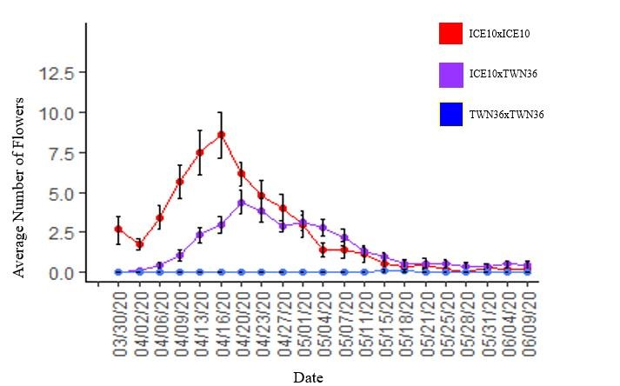
Figure 5: Average number of flowers based on ICE10xICE10, TWN36xTWN36, and ICE10xTWN36 genotypes in the hot temperature chamber (29°C). Under elevated temperatures, all plants saw reduction in the average number of flowers produced over time. ICE10xTWN36 hybrids still produce an average amount of flowers intermediate to the parent species.
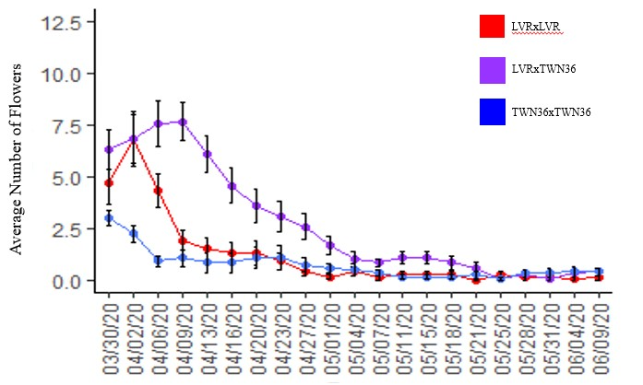
Figure 6: Average number of open flowers counted for the LVRxLVR, TWN36xTWN36, and LVRxTWN36 genotypes of the control temperature (23°C). All genotypes tend to produce their highest average amount of flowers early, but the LVRxTWN36 hybrids outperformed both parent species.

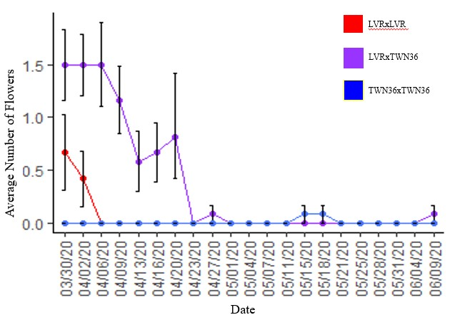
Figure 7: Average number of open flowers counted in the LVRxLVR, TWN36xTWN36, and LVRxTWN36 genotypes under elevated temperature (29°C). Under elevated temperatures, all genotypes saw a reduction in the average number of flowers produced, but the LVRxTWN36 cross type still outperforms both parent species.

Temperature affected the flowering success of species and hybrids in the M. tilingii complex
I found that temperature, cross, time, and their interactions played significant roles in flowering (Table 8). Almost all crosses saw statistically significant increases or decreases to the number of flowers produced based on the temperature they were grown in (Tables 9 & 10; Figure 8). Progeny from nearly all control crosses produced fewer flowers in the elevated temperature. Progeny from ICE10 and UTC1 control crosses experienced approximately 15-17% reductions to the average number of open flowers produced, while progeny from LVR control crosses experienced as much as a 52% reduction in the average number of flowers produced. The only control cross that saw an increase in the average number of flowers produced was
TWN36xTWN36, which experienced a 25% increase. However, all hybrid progeny except LVRxTWN36 hybrids produced higher average amounts of flowers (Table 10; Figure 8).
LVRxTWN hybrids experienced a 51% reduction in the average amount of open flowers, while ICE10xUTC1.2 and ICE10xTWN36 hybrids experienced 34% and 12% increases in the flowers produced, respectively. Two hybrid crosses in particular- ICE10xUTC1.1 and ICE10xUTC1.3- tripled to quadrupled the average amounts of open flowers produced.
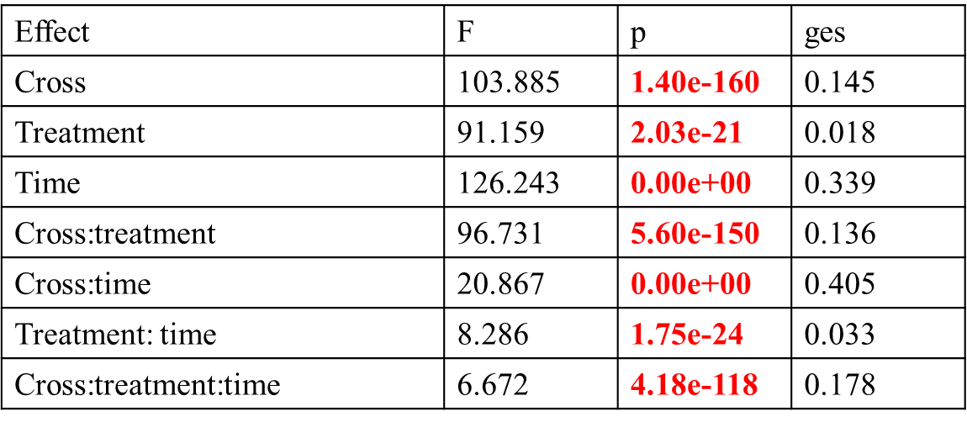
Table 8: Effect(s) of cross, temperature treatment, time, and their interactions on the average number of flowers produced by progeny from control crosses and hybrid progeny. Statistically significant values are indicated in red. Cross, treatment, time, and their interactions had significant effects on the average number of flowers produced.

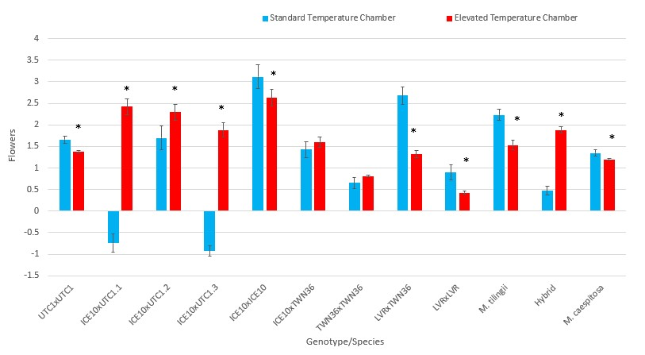
Figure 8: Average number of flowers produced for the progeny of control cross, hybrid progeny, and grouped M. tilingii, M. caespitosa, and hybrid plants. All crosses except for ICE10xTWN36 and TWN36xTWN36 experienced statistically significant increases or decreases to the average number of open flowers produced due to the temperature they were raised in.
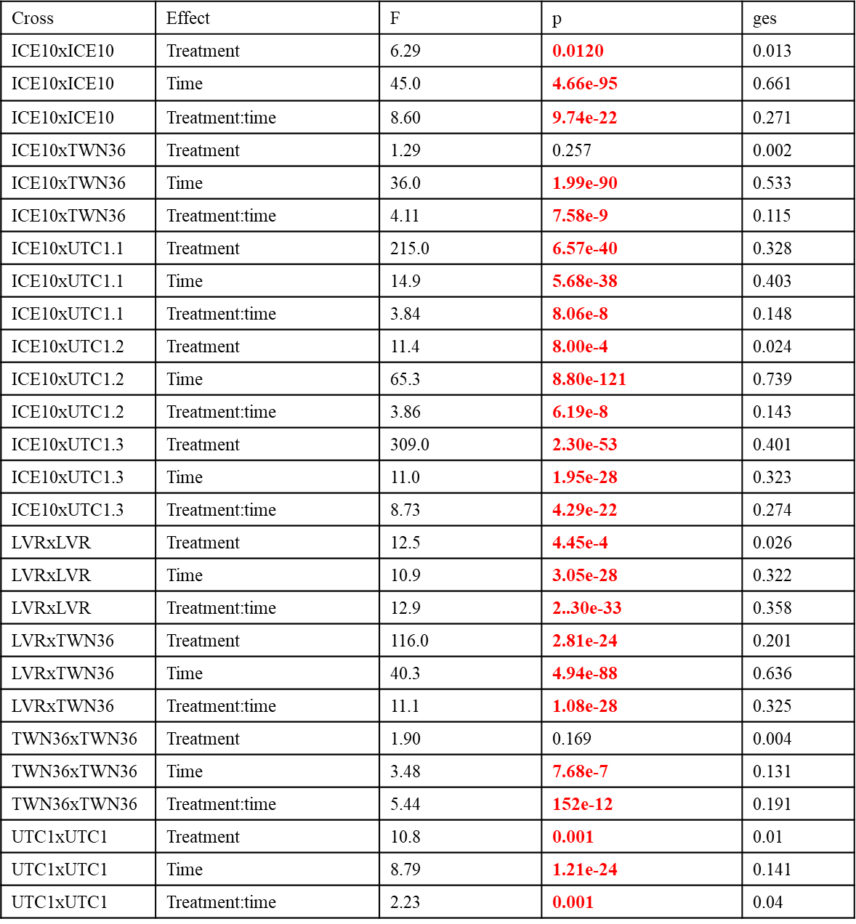
Table 9: Post-hoc test generating pairwise differences based on treatment, time, and their interactions. Statistically significant values are indicated in red. For all crosses but two- ICE10xTWN36 and TWN36xTWN36- temperature, time, and their interactions had significant effects on the average number of flowers produced.

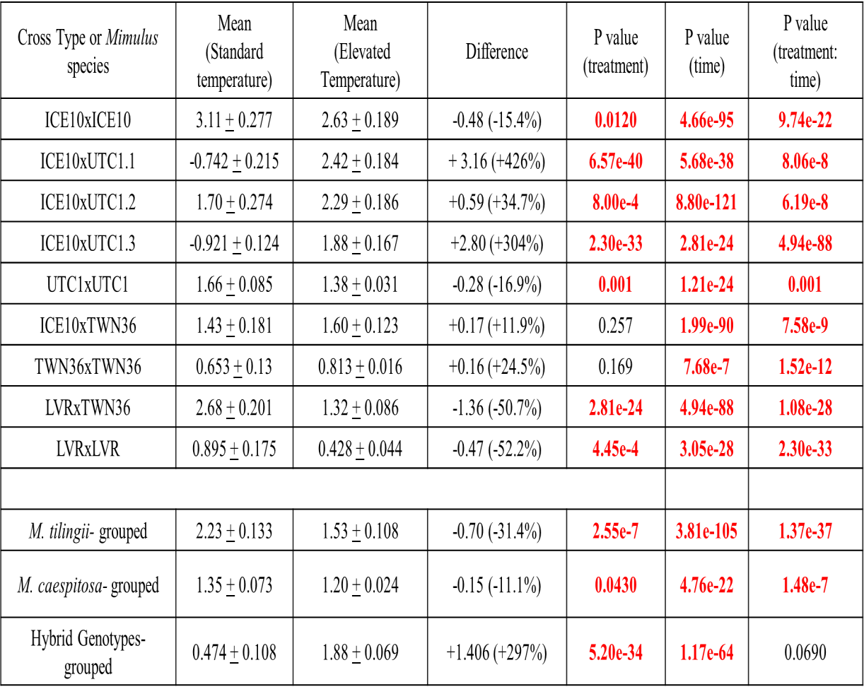
Table 10: Summary of statistics and changes in the amounts of flowers produced for crosses, as well as combined M. tilingii, M. caespitosa, and hybrid crosses. Statistically significant p values are indicated in red.

Discussion
An important question is how species evolve and diverge over time. One post-zygotic reproductive barrier, hybrid necrosis, has been the subject of much study in recent years as a possible method of speciation. Hybrid necrosis acts as a reproductive isolating behavior by reducing plant fitness- tissue lesioning, stunted growth and development, and plant death- to the extent that most hybrids are unable to reach maturity. (Bomblies & Weigel, 2007; Chen et al., 2014; Mizuno et al., 2011). Additionally, its role as a postzygotic gene flow barrier further prevents hybridization between two species that are able to overcome prezygotic reproductive barriers (Bomblies & Weigel, 2007; McNaughton & Harper, 1960). In this study, I characterized differences in flowering as phenotypes of the hybrid necrosis in two monkey flower species, M. tilingii and M. caespitosa. I observed that hybrid necrosis in the M. tilingii complex shortens the flowering time of plants, as well as diminishes the average number of flowers produced in specific genotypes. Additionally, an increase in temperature had a negative effect on flowering for the progeny of most control crosses used in the study. However, the increase in temperature was able to increase the number of open flowers produced by most hybrid progeny, as well as rescue two hybrid crosses from necrosis by improving flowering period and the average number of flowers produced by those genotypes. Below, I discuss the possibility that the hybrid necrosis observed between M. tilingii and M. caespitosa is influenced by underlying epistatic interactions within the hybrids, as well as the possibility for those negative interactions to be rescued through environmental changes such as elevated temperature.
For many flowering plant species like Mimulus, the timing and success of flowering is critical to reproductive success (Amasino, 2017). Hybrids in my study that suffered from necrosis experienced shorter flowering periods and produced fewer flowers when compared to maternal lines. In crosses between M. tilingii and M. caespitosa, we observed varying degrees of flowering defects associated with hybrid necrosis. Past research has shown that it is standard for the severity of hybrid necrosis phenotypes to differ and be classified into different types based on genetic background and severity (Mizuno et al., 2010; Takumi & Mizuno, 2011; Bomblies et al., 2007). Hybrid crosses between LVR and TWN36 did not experience any symptoms of necrosis. On the contrary, these hybrid plants outperformed the parent species in the average number of open flowers produced and in the length of flowering, regardless of which temperature they were grown in. In contrast, when ICE10 was used in interspecific crosses, especially in combination with UTC1, hybrids tended to produce the same or fewer flowers than the maternal line. When crossed with TWN36, hybrids consistently produced intermediate amounts of flowers. Based on these flowering patterns, we determined that only interspecific cross combinations between ICE10 and UTC1 produced offspring showing necrosis phenotypes. This polymorphism within species for hybrid necrosis between species is consistent with previous research showing that hybrid necrosis within the M. tilingii complex is variable (Sandstedt et al., 2020).
In previous studies, elevated temperatures have often been shown to alleviate the effects of hybrid necrosis (Phillips, 1997; Bomblies et al., 2007; Jeuken et al., 2009; Mino et al., 2002; Phillips, 1977; Todesco et al., 2014; Yamada et al., 2003; Mino et al., 2002). Elevated temperature has an effect on the success of flowering in the M. tilingii complex and has the potential to rescue hybrids from hybrid necrosis. Almost all control crosses experienced reductions to the average amount of flowers produced when grown under elevated temperatures. However, most hybrid crosses (4/5) produced more flowers in elevated temperatures and were able to flower longer relative to standard growing temperatures (2/5). Two crosses in particular- ICE10xUTC1.1 and ICE10xUTC1.3- experienced unparalleled increases in the number of open flowers, as well as longer flowering periods. The other ICE10xUTC1 hybrid remained consistently intermediate in the amounts of flowers it produced, and its flowering period unchanged. The large increase and recovery of flowering in two of the three ICE10xUTC1 hybrids suggests that hybrid necrosis is present and reversible in specific interspecific crosses between M. tilingii and M. caespitosa.
The differences in flowering success of the between hybrid genotypes suggests that the presence of the necrosis is only observed in specific genotypes in the M. tilingii complex. Additionally, the observation that not all ICE10xUTC1 hybrids experienced severe necrosis suggests that the UTC1 parent was heterozygous for necrosis alleles, and that two sibs-UTC1.1 and UTC1.3- inherited those alleles. This implies that the genetic basis of hybrid necrosis between M. tilingii and M. caespitosa is relatively simple, involving one or two genes, otherwise it would be highly unlikely that the sibs would segregate for discrete phenotypes.
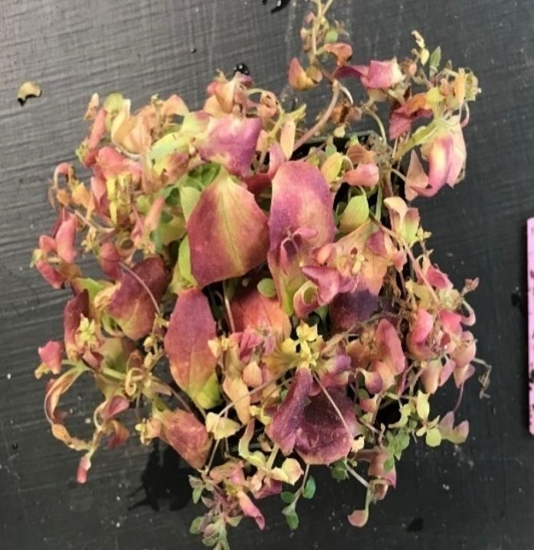
Maintaining immune responses while balancing a healthy metabolism can cause instability of the immune system and result in autoimmune disorders and retarded growth (Alcazar & Parker, 2011). In hybrids, this burden between balancing immune responses and energy expenditure can become even more pronounced when the immune systems of the two parent species mismatch within a hybrid background, leading to the phenotypes seen in
hybrid necrosis. Two of the genotypes of our research-
Figure 9: Necrotic ICE10xUTC1.3 hybrid from
ICE10xUTC1.1 and ICE10xUTC1.3- were able to the standard growth temperature chamber at the end of the study. Future directions might include
recover from the observed necrosis under elevated quantifying the necrotic (purple) leaves. temperature conditions, while other genotypes performed worse. Our research shows that the hybrid necrosis observed in the M. tilingii complex is able to be reversed or avoided through an increase in temperature outside of normal growing conditions. However, our study was limited by only studying one phenotype of hybrid necrosis (flowering patterns), and it may be of future interest to measure other phenotypic changes such as leaf density and color, budding, or plant volume to obtain a more comprehensive understanding of hybrid necrosis in the M. tilingii complex. Similarly, because our study only used two species of the tilingii complex, it would be of interest to see if hybrid necrosis is also observed in the third species of the complex- Mimulusminor. Having a more comprehensive understanding of hybrid necrosis in the M. tilingii complex could allow for a clearer picture of the complex interactions among the different maternal lines and populations, and why the necrosis appears to only affect genotypes.
Rapid speciation is expected to be facilitated by environmental changes as species adapt differently to changing habitats (Stewart, 2009; Levin, 2019). Although more research is needed to determine the exact genetic cause of hybrid lethality within the Mimulus tilingii complex, it would be of great interest to determine how temperature may affect future speciation among Mimulus and other plant species. As climate change affects different habitats, it may allow for previously allopatric species to come in contact once again (Anderson, 1948). Although the speciation process is thought of as a result of a physical separation caused by geographic barriers, it may be of interest to look at the effect climate change may have on habitat change and consequent speciation.

References
- Alcázar R., Garcia, A., Parker, J., Reymond, M. (2009). Incremental steps toward incompatibility revealed by Arabidopsis epistatic interactions modulating salicylic acid pathway activation. Proc. Natl. Acad. Sci. U.S.A., 106, pp. 334-339
- Alcázar, R., & Parker, JE. (2011). The impact of temperature on balancing immune responsiveness and growth in Arabidopsis. Trend Plant Sci, 16, pp. 666-675.
doi:10.1016/j.tplants.2011.09.001.
- Amasina, R. (2017). Focus on Flowering and Reproduction. Plant Physiology, 173(1), pp. 1-4
- Anderson, E. (1948). Hybridization of the habitat. Evolution, 2, pp 1-9.
- Bomblies, K. (2009). Too much of a good thing? Hybrid necrosis as a by-product of plant immune system diversification. Botany, 87(11), pp 1013-1022.
- Bomblies, K., Lempe, J., Epple, P., Warthmann, N., Lanz, C., Dangl, J., Weigel, D. (2007). Autoimmune response as a mechanism for a Dobzhansky-Muller-type incompatibility syndrome in plants. PLoS Biol. 5, pp. 1962-1972.
- Bomblies K, Weigel D. (2007). Hybrid necrosis: autoimmunity as a common barrier of gene flow barrier in plants. Nat Rev Genet., 8, pp. 382-393. doi:10.1038/nrg2082.
- Chen, C., Chen, H., Lin, Y-S., Shen, J-B., Shan, J-X., et al. (2014). A two-locus interaction causes interspecific hybrid weakness in rice. Nature Communication, 5, pp.
3357. doi10.1038/ncomms4357.
- Coyne, J.A. & Orr, H.A. (1998) The evolutionary genetics of speciation. Philos Trans R
Soc Lond B Biol Sci., 353(1366), pp. 287-305.
- Dodds, P., & Rathjen, J. (2010). Plant immunity: towards an integrated view of plantpathogen interactions. Nat Rev Genet., 11, pp. 539-548. doi: 10.1028/nrg2812.
- Dubey, N., Singh, K. (2018). Role of NBS-LRR Proteins in Plant Defense. In: Singh A.,
Singh I. (eds) Molecular Aspects of Plant-Pathogen Interaction. Springer, Singapore. https://doi.org/10.1007/978-981-10-7371-7_5
- Guo, Y-L., Fitz, J., Schneeberger, K., Ossowski, S., et al. (2011). Genome-wide comparison of nucleotide-binding site-leucine-rich repeat-encoding genes in Arabidopsis.
Plant Physiol., 157, pp. 757-769. doi:10.1104/pp.111.181990.
- Grant, A.L. (1924). A monograph of the genus Mimulus. Ann Missouri Bot. Gard., 11, pp. 99-389
- Hatfield, J., & Prueger, J. (2015). Temperature extremes: Effect on plant growth and development. Weather and Climate Extremes, 10, pp. 4-10.
- Hua, J., Grisafi, P., Cheng, S-H., Fink, G. (2001). Plant growth homeostasis is controlled by the Arabidopsis BON1 and BAP1 genes. Genes Dev., 15, pp. 2263-2272
- Jabob, F., Vernalid, S., Mackawa, T. (2013). Evolution and conservation of plant NLR functions. Frontiers in immunology, 4, 297.
- Jeuken, M., Zhang, N., McHale, L., Pelgrom, K., et al. (2009). Rin4 Causes Hybrid Necrosis and Race-Specific Resistance in an Interspecific Lettuce Hybrid. Plant Cell
2009; 21; 3368-3378
- Johnson, N.A & Wade, J.J. (1996). Genetic covariances within and between species: indirect selections for hybrid inviability. J. Evol. Biol, 9, pp. 205-214.
- Jones, J., & Dangl, J. (2006). The plant immune system. Nature, 444, pp. 323-329.
doi:10.1038/nature05286.
- Levin, D. (2019). Plant speciation in the age of climate change. Annals of Botany, 124(5), pp 769-775.
- McNaugton, I.H. & Harper, J.L. (1960). The comparative biology of closely related species living in the same area. II. Aberrant morphology and virus-like syndrome in hybrids between Papaver rhoeas L. and P. dibium L. New Phytol. 59, pp. 27-41.
- Mino, M., Maekawa, K., Ogawa, K., Yamagishi, H., Inoue, M. (2002). Cell death processes during expression of hybrid lethality in interspecific F hybrid between
Nicotiana gossei Domin and Nicotiana tabacum. Plant Physiol., 130, pp. 1776–1787.
- Mizuno, N., Shitsukawa, N., Hosogi, N., Park P., Takumi, S. (2011). Autoimmune response and repression of mitotic cell division occur in interspecific crosses between tetraploid wheat and Aegilops tauschii Coss. That show low temperature-induced hybrid necrosis. The Plant Journal, 68, pp. 114-128.
- Mizuno, N., Hosogi, N., Park, P., Takum, S. (2010). Hypersensitive Response-Like Reaction Is Associated with Hybrid Necrosis in Interspecific Crosses between Tetraploid Wheat and Aegilops tauschii Coss. PLoS One, 5(6).
- Nesom, G. (2012) Taxonomy of Erythranthe sect. Simiola (Phrymaceae) in the USA and
Mexico. Phytoneuron, 40, pp. 1-123
- Nesom, G. (2013). New distribution for Erythranthe (Phrymaceae). Phytoneuron, 67, pp.
1-15.
- Nesom, G. (2014). Updated classification of hypothetical phylogeny of Erythranthe sec. Simiola (Phrymaceae). Phytoneuron, 81, pp 1-6.
- Nesom, G. (2019). Taxonomic status of Erythranthe minor (Phrymaceae). Phytoneuron,
32, pp. 1-7.
- Nesom, G., Fraga, N., Barker, W., Beardsley, P., et al. (2019). Response to “The case for the continued use of the genus name Mimulus for all monkeyflowers.” Taxon, 68(4), pp.
624-627.
- Phillips, L. (1977). Interspecific incompatibility in Gossypium. IV. Temperatureconditional lethality in hybrids of G. klotzschianum . Am J Bot., 64, pp. 914–915
- Pieterse, C., Leon-Reyes, A., Van der Ent, S., Van Wees, S. (2009). Networking by small-molecule hormones in plant immunity. Nat. Chem. Biol., 5, pp. 308-316.
- Ritland, C. & Ritland, K. (1989). Variation of sex allocation among eight taxa of the Mimulus guttatus species complex (Scrophulariaceae). American Journal of Botany, 76(12), pp. 1731-1739.
- Ritland, K. (1989). Genetic differentiation, diversity, and inbreeding in the mountain monkeyflower (Mimulus caespitosus) of the Washington Cascades. Canadian Journal of
Botany, 67(7), pp. 2017-2024.
- Safran, R.J. & Nosil, P. (2012). Speciation: The Origin of New Species. Nature
Education Knowledge, 3(10), 17.
- Sandstedt, G., Wu, C., Sweigart, A. (2020). Evolution of multiple postzygotic barriers between species of the Mimulus tilingii complex. Evolution, https://doi.org/10.1111/evo.14105
- Stewart, J. (2009). The evolutionary consequence of the individualistic response to climate change. Journal of Evolutionary Biology, 22, pp 2363-2375.
- Takumi, S. & Mizuno, N. (2011). Low temperature-induced necrosis shows phenotypic plasticity in wheat triploid hybrids. Plant Signal Behav., 6(10), pp. 1431-1433.
- Todesco M, Blasubramanian S, Hu TT, Traw MB, Horton M, et al. (2010). Natural allelic variation underlining a major fitness tradeoff in Arabidopsis thaliana. Nature, 465, pp. 632-636.
- Todesco M, Kim S-T, Chae E, Bomblies K, Zaidem M, et al. (2014). Activation of the Arabidopsis thaliana Immune System by Combinations of Common ACD6 Alleles. PLoS
Genet., 10(7): e1004459. doi:10.1371/journal.pgen.1004459
- Vickery, R. (1974). Crossing barriers in the yellow monkey flowers in the genus Mimulus
(Scrophularicaceae). Genet. Lect., 3, pp. 33-83.
- Wade, M. J. (2002). A gene’s eye view of epistasis, selection and speciation. Journal of
Evolutionary Biology, 15(3).
- Wade, M.J. (1992). Sewall Wright: gene interaction and the Shifting Balance Theory. In Oxford Series of Evolutionary Biology (J. Antonovics & D. Futuyma, eds), Vol 8, pp. 35-
62. Oxford University Press, Oxford.
- Yamada, T., & Marubashi, W. (2003). Overproduced ethylene causes programmed cell death leading to temperature-sensitive lethality in hybrid seedlings from the cross Nicotiana suaveolens x N. tabacum. Planta, 217, pp. 690–698

